Motor/Inductor Board Rev 3.6 Layout

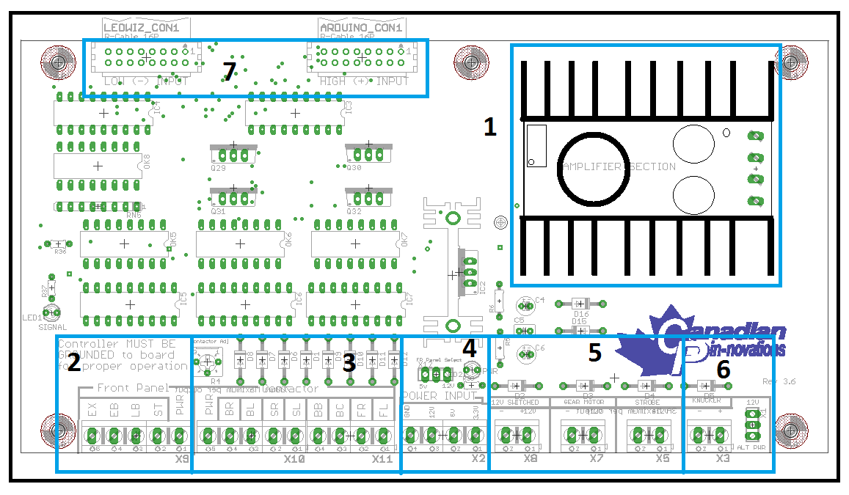

1 - DC to DC Amplifier
2 - Front Panel Button Light Connections
3 - Contactor Force Feedback Connection
4 - Power INPUT Bank
5 - High Power OUTPUT Bank
6 - Replay Knocker OUTPUT
7 - Control Signal INPUT Connectors

1. DC to DC Amplifier

The DC to DC Amplifier is used to convert the 12V coming into the board from the Flasher Board into a MAXIMUM of 32V DC for use in powering the replay knocker and contactors. The MAXIMUM OUTPUT CURRENT of the amplifier cannot exceed 10A.
Your board comes preset to 32V and it is recommended that you leave it set to that unless you require a lower voltage for your replay knocker.
If you need to adjust the voltage, it can be adjusted by turning the adjustment screw on the variable resistor on the amplifier daughterboard as illustrated below.
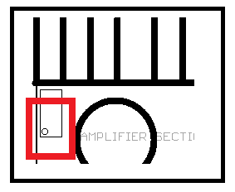
Turning the screw clockwise will increase the voltage (not recommended). Turning the screw counter-clockwise will decrease the voltage. While it is possible to adjust the voltage while the circuit is live, care should be taken to avoid shorting the screwdriver against the heatsink and other circuitry.

Lowering the voltage below the required voltage for your contactors will cause the contactors to cease operation.

2. Front Panel Lighting Outputs
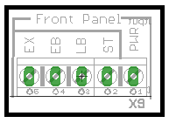
The front panel lighting outputs are used to provide ROM controlled illumination to the Start, Launch, Extra Ball and Exit Buttons on your cab.
In the LEDWiz Control.ini file, these outputs are arranged as follows:

1 - Start Button
2 - Launch Ball Button
3 - Extra Ball Button
4 - Exit Button

This is also the order that they are arranged on the INPUT connectors at the top of your board.
The output voltage connection for these buttons is found to the RIGHT of the output bank.
This voltage is selectable between the 2 most common voltages used, 12VDC and 5VDC by jumpering the connection found above the PWR INPUT bank as seen below.
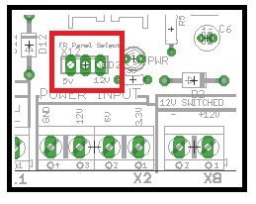
Placing the jumper across the Left outer and center pin will select 5VDC operation of your lights.
Placing the jumper across the Right outer and center pin will select 12VDC operation of your lights.
If a voltage other than the ones listed is required, simply connect the + side of your lights to that voltage supply.

3. Contactor Force Feedback
Voltage for the force feedback is supplied by the DC to DC Amplifier found in section 1.
The voltage is adjustable between 11VDC and 27VDC.
This adjustment can be made by turning the adjustment screw located immediately above the contactor output bank as shown below.
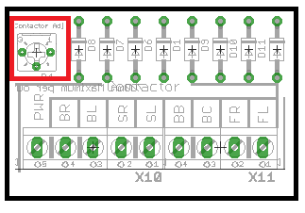
Turning the screw clockwise increases the output voltage while turning it counter clockwise decreases the output voltage.
Your board comes preset to 24VDC with 1N4007 (1A) diode protection on all contactor outputs.
In the LEDWiz Control.ini file, these outputs are arranged as follows:
5 - Slingshot - Left
6 - Slingshot Right
7 - Bumper Jet - Left
8 - Bumper Jet - Right
9 - Flipper - Left
10 - Flipper - Right
11 - Bumper Jet - Center
12 - Bumper Jet - Back (less noise)

Once again this configuration matches the pin location on the INPUT connectors from your controller.
4. Power INPUT Bank

The power input bank connects to the power INPUT/OUTPUT bank of the Flasher Board.

5. High Power Output Bank

The high power outputs are driven by 50V 60A capable MosFET transistors. These drivers have been chosen as they eliminate the need for heatsinks at the current levels that the average pincab operates at. While these ratings allow the actual chip to handle that kind of power, the circuit board is designed to run a MAXIMUM of 4A per driver safely.
Each high power output is protected by a 1N4007 (1A) diode.

In the LEDWiz Control.ini file, these outputs are arranged as follows:
13 - Replay Knocker (see next section)
14 - Strobe (12VDC)
15 - Gear Motor (12VDC)
16 - Spare (12VDC)
Once again this configuration matches the pin location on the INPUT connectors from your controller.

6. Reply Knocker Output

Voltage for the Replay knocker is supplied by the DC to DC amplifier.
The MAXIMUM ALLOWABLE VOLTAGE IS 32VDC.
Voltage is selectable between 12VDC (fixed voltage from ATX power supply) and an adjustable voltage supplied by the amplifier. This selection can be made by moving the jumper located to the right of the output connection as seen in the figure below.
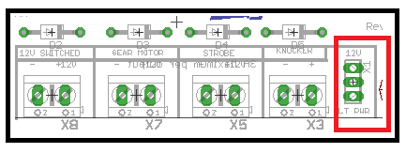
Placing the jumper across the center and upper pins selects fixed 12VDC.
Placing the jumper across the center and lower pins selects adjustable voltage (32VDC MAX).
Removing the jumper completely allows for connection of the replay knocker to an external power supply. JUMPER MUST BE REMOVED WHEN USING AN EXTERNAL SUPPLY.
In the LEDWiz Control.ini file, these outputs are arranged as follows:
13 - Replay Knocker
Once again this configuration matches the pin location on the INPUT connectors from your controller.

7. INPUT connectors

The input connectors supply the signal from the controller to the board.
The connector on the left is for Negative (LOW) input signals from controllers such as the LEDWiz.
The connector on the right is for Positive (High) input signals from controllers such as the Arduino.
The board can only process one or the other type signal at a time. DO NOT CONNECT BOTH CABLES to separate controllers at the same time or damage will occur to your controller.

The pinout for both the LOW and HIGH connectors are the same and as follows:

Upper Row right to left 1 3 5 7 9 11 13 15
Lower Row right to left 2 4 6 8 10 12 14 16

In the LEDWiz Control.ini file, these outputs are arranged as follows:

1 - Start Button
2 - Launch Ball Button
3 - Extra Ball Button
4 - Exit Button
5 - Slingshot - Left
6 - Slingshot Right
7 - Bumper Jet - Left
8 - Bumper Jet - Right
9 - Flipper - Left
10 - Flipper - Right
11 - Bumper Jet - Center
12 - Bumper Jet - Back (less noise)
13 - Replay Knocker (see next section)
14 - Strobe (12VDC)
15 - Gear Motor (12VDC)
16 - Spare (12VDC)

Once again this configuration matches the pin location on the INPUT connectors from your controller.

